Contents
Abstract Classes & Interfaces

Abstract Classes & Interfaces
Abstract Classes | Interfaces
 | 
Has abstract and non-abstract methods | Has only abstract methods
May contain non-final variables. | Variables declared in a java interface are by default final
Have final, non-final, static and non-static variables. | Has only static and final variables.
Abstract class can be extended using keyword “extends”. | Interface can be implemented using keyword “implements”
A Java abstract class can have class members like private, protected, etc. | Members of a Java interface are public by default.
A class can extend only one abstract class. | A class can implement more than one interface.
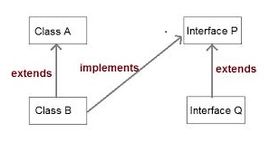
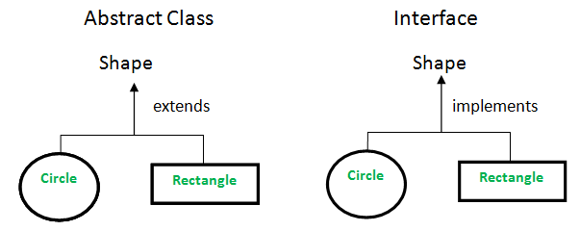
Default methods
Interfaces can define default methods. A default method in an interface is a method with implementation. Use “default “keyword in method signature to make it default.
interface xyz {
default return-type method-name(argument-list) {
------------------}}
static methods
Along with the default methods an Interface can also have static methods. The syntax of static method is similar to default method, where static keyword will replace default.

interface xyz {
static return-type method-name(argument-list) {
------------------}}

